

[Artificial Intelligence in G](https://doi.org/10.1016/j.aiig.2022.12.004)e[osciences 3 (2022) 203–208](https://doi.org/10.1016/j.aiig.2022.12.004)   
 Contents lists available at ScienceDirect   
Artificial Intelligence in Geosciences

journal homepage: [www.keaipublishing.com/en/journals/artificial-intelligence-in-geoscience](http://www.keaipublishing.com/en/journals/artificial-intelligence-in-geosciences)s

High resolution pre-stack seismic inversion using few-shot learning Ting Chen*, Yaojun Wang, Hanpeng Cai, Gang Yu, Guangmin Hu   
*University of Electronic Science and Technology of China, China*

|  |  |
| --- | --- |
| A R T I C L E I N F O | A B S T R A C T |
| *Keywords:*  Few-shot learning  Artificial neural network Seismic inversion | We propose to use a Few-Shot Learning (FSL) method for the pre-stack seismic inversion problem in obtaining a high resolution reservoir model from recorded seismic data. Recently, artificial neural network (ANN) demon-strates great advantages for seismic inversion because of its powerful feature extraction and parameter learning ability. Hence, ANN method could provide a high resolution inversion result that are critical for reservoir characterization. However, the ANN approach requires plenty of labeled samples for training in order to obtain a satisfactory result. For the common problem of scarce samples in the ANN seismic inversion, we create a novel pre-stack seismic inversion method that takes advantage of the FSL. The results of conventional inversion are used as the auxiliary dataset for ANN based on FSL, while the well log is regarded the scarce training dataset. According to the characteristics of seismic inversion (large amount and high dimensional), we construct an arch network (A-Net) architecture to implement this method. An example shows that this method can improve the accuracy and resolution of inversion results. |

**1. Introduction**

High resolution pre-stack seismic inversion is a major technology for reservoir characterization (Zong et al., 2012). Due to the limitation of seismic data quality, it is difficult to obtain a high resolution reservoir parameter from seismic data (Alemie and Sacchi, 2011). Previous studies found that introducing prior information or reasonable rock physical model into the inversion framework can improve the resolution of inversion results (Hampson et al., 2005; She et al., 2019; de Fig-ueiredo et al., 2019). However, the current methods need to design mathematical models satisfying different assumptions, they are only applicable to some specific scenarios, but difficult to complex geological areas.

The current research shows that ANN has powerful feature extraction and parameter learning ability, and the inversion methods combined with ANN are more efficient than conventional one. It has been used to obtain velocity model from the CSP gathers (R¨oth and Tarantola, 1994; Araya-Polo et al., 2018). A variant of ANN called recurrent neural network (RNN) has been used for full-waveform inversion (Richardson, 2018). Chen et al. (2019) applied iterative deep neural networks (DNN) to inverse seismic wavelet and reflectivity. To make network more perfect, the training process requires to have a sufficient amount of valid labeled data (Goodfellow et al., 2016; Dai et al., 2019). ANN has a huge development in the field of image, partly because it is easy to get valid

* Corresponding author.

*E-mail address:* [ting.chen.seven@gmail.com](mailto:ting.chen.seven@gmail.com) (T. Chen).

labeled data in this field, but it is very expensive to get in the field of geophysics. To alleviate the problem of scarce samples, adding con-straints to the ANN inversion framework to improve network general-ization ability has become the choice of many researchers. For example, the ANN framework with initial models as constraints (Zhang et al., 2021); A convolution neural network (CNN) employing a physics-guided approach and data drive (Biswas et al., 2019; Sun et al., 2021). Song et al. (2022) proposed an inversion framework based on semi-supervised learning. In this work, we employ another ANN learning architecture named FSL for high resolution pre-stack seismic inversion of reservoir parameters.

The ANN algorithms usually require hundreds or thousands of su-pervised samples to ensure generalization ability (Lu et al., 2020). The FSL is significant and challenging in the field of ANN. Due to the mature mathematical principle, conventional inversion method could integrate well log and seismic data in reasonable good manner. The results of conventional inversion are used to construct the auxiliary dataset, and a few of accurate well log is regarded as the scarce training dataset. In order to adapt to the characteristics of ANN seismic inversion with large amount data but few labeled samples, we create a new A-Net architec-ture to implement the method. This network firstly increases the number of the convolution kernel layer by layer to enlarge the feature quantity, and then reduces the number of the convolution kernel to extract high-dimensional features. FSL can still achieve a satisfactory result with

<https://doi.org/10.1016/j.aiig.2022.12.004>   
[Received 23 November 2022; Received in r](https://doi.org/10.1016/j.aiig.2022.12.004)evised form 27 December 2022; Accepted 27 December 2022   
Available online 31 December 2022   
2666-5441/© 2022 [The Authors. Publishing services by Elsevier B.V.](http://creativecommons.org/licenses/by-nc-nd/4.0/) on behalf of KeAi Communications Co. Ltd. This is an open access article under the CC BY-NC-ND license (<http://creativecommons.org/licenses/by-nc-nd/4.0/>).

*T. Chen et al.*  *Artificial Intelligence in Geosciences 3 (2022) 203–208*

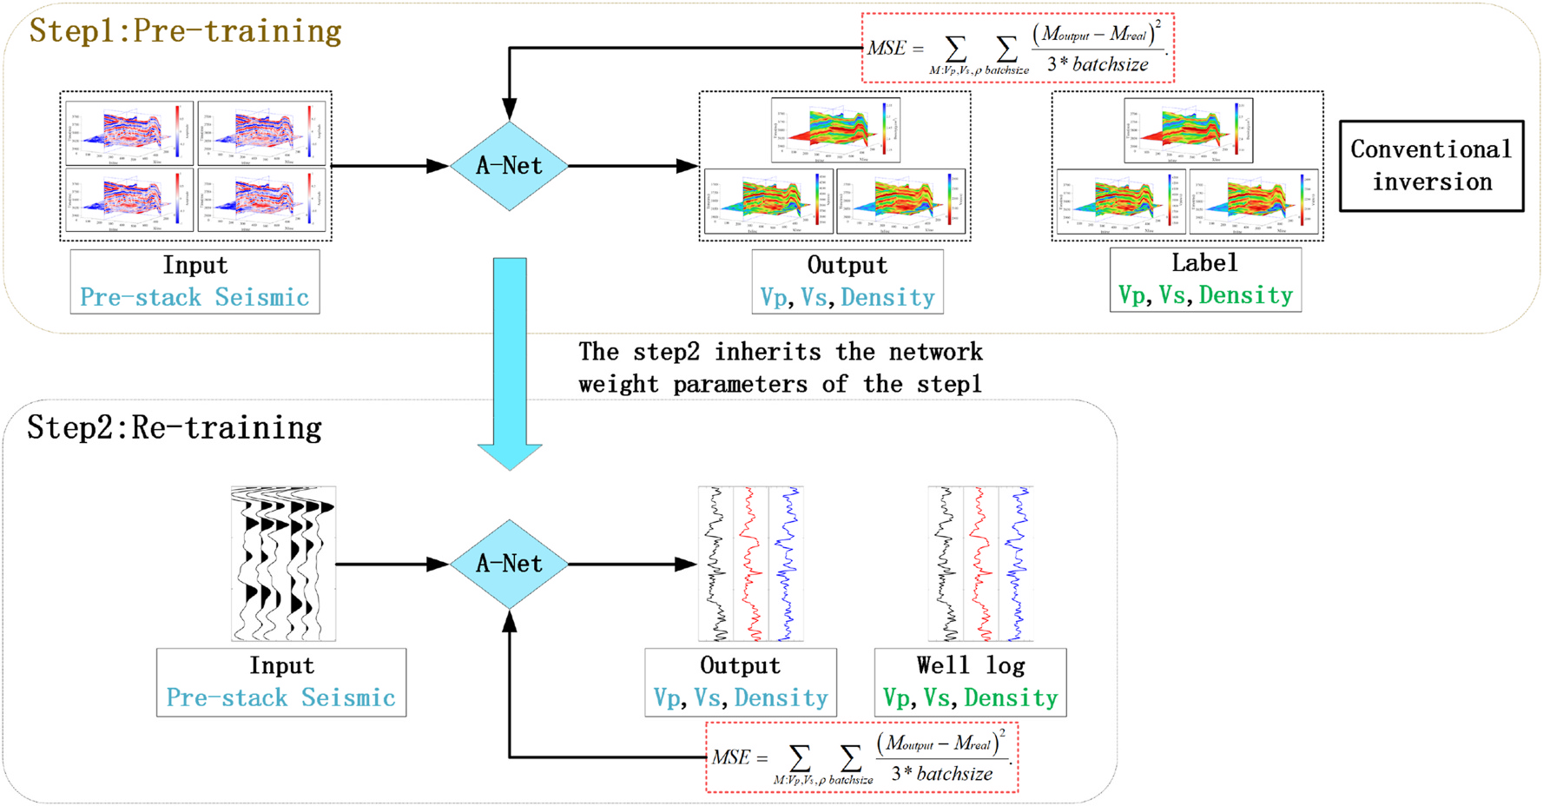

**Fig. 1.** The framework of the proposed method.

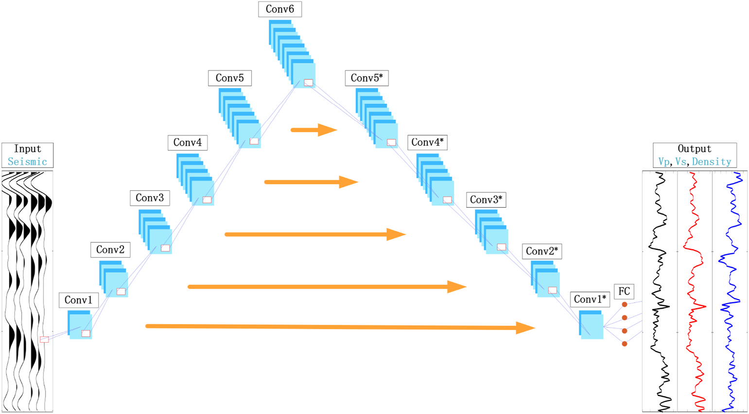

**Fig. 2.** A-Net architecture for pre-stack seismic inversion. The pre-stack seismic angle gathers is the input of the network and the reservoir parameters curve *Vp*, *Vs* and *ρ* is the output, that compare with prepared or true well log.

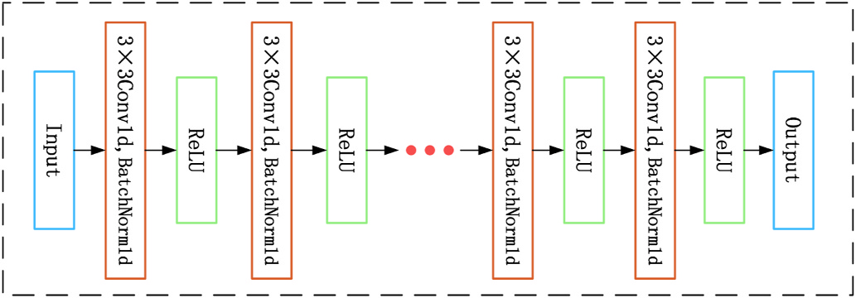

**Fig. 3.** The convolutional unit architecture. Input is the pre-stack seismic angle gathers or an output from a previous unit, and output is the input to the next unit.

few samples. This method is successfully applied to a filed data set from northwest of China by effectively improving the resolution of inversion results.

204

*T. Chen et al.*  *Artificial Intelligence in Geosciences 3 (2022) 203–208*

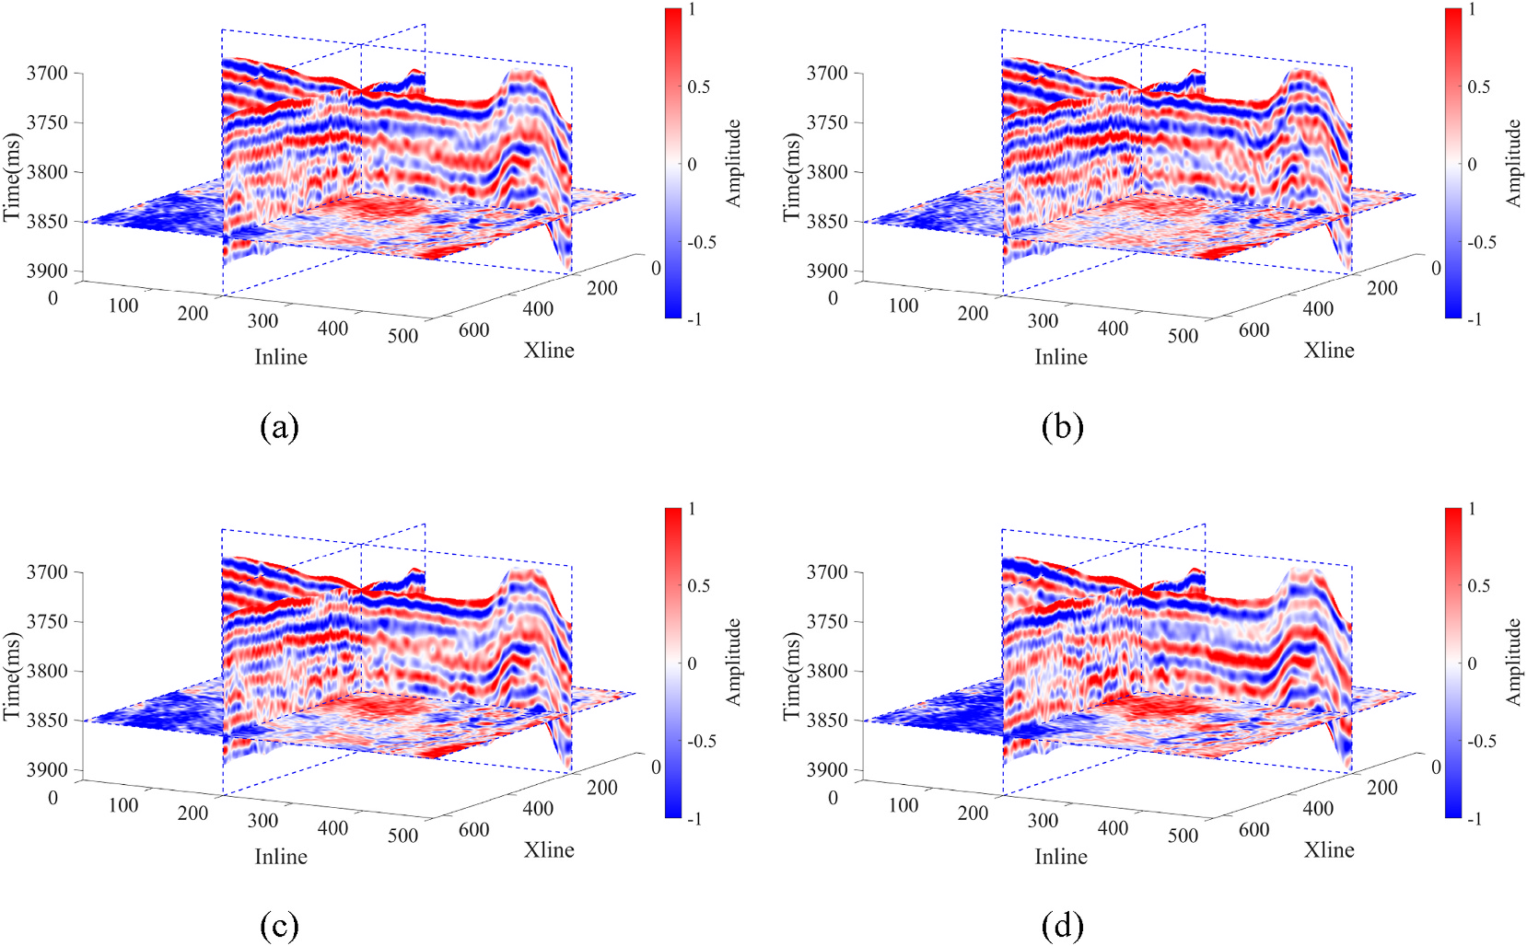

**Fig. 4.** Post-stack and pre-stack seismic via various angles. (a) post-stack seismic data set; (b) near angle-stack seismic data set; (c) middle angle-stack seismic data

set; (d) far angle-stack seismic data set.

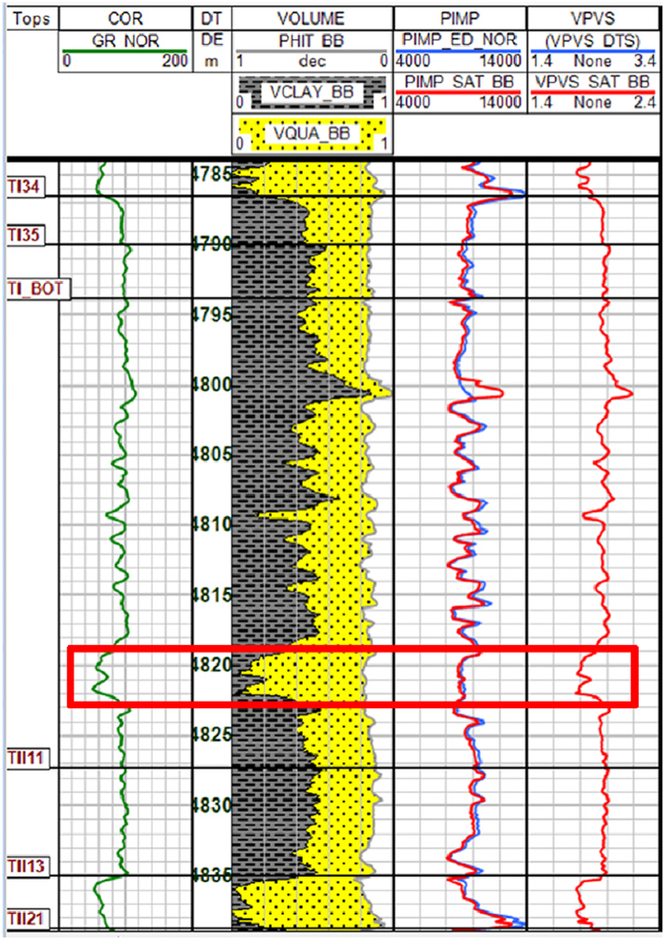

**Fig. 5.** Log analysis of well. The red rectangle in the plot is the location of the TII0 gas formation.

the hidden relationship between pre-stack seismic data and reservoir parameters can be learned by neural network. As shown in the top dotted box of Fig. 1, the predicted output of the network is compared with prepared label. We use the mean square error (MSE) as the loss function to measure the distance between the outputs and the labels.

*2.2. Step 2: Re-training for application*

When the pre-training step is completed, the trained network is retrained using the well log. The workflow is shown in the bottom box of

205

*T. Chen et al.*  *Artificial Intelligence in Geosciences 3 (2022) 203–208*

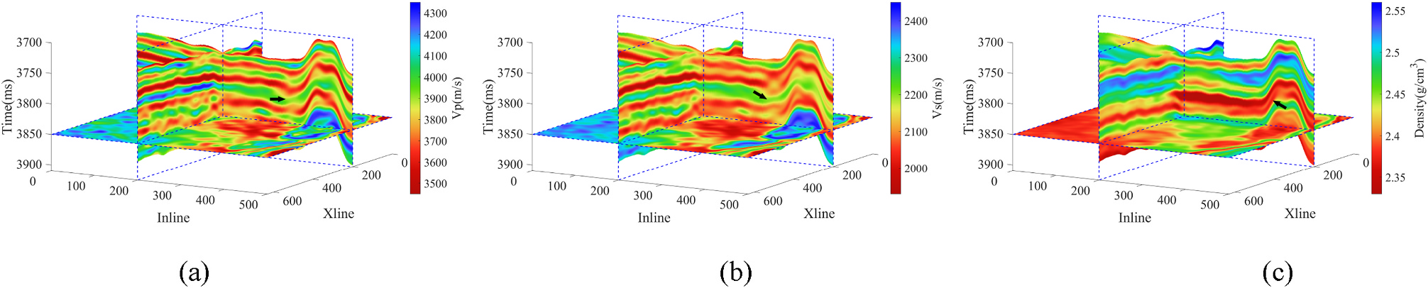

**Fig. 6.** The conventional inversion results of reservoir parameters. (a) *Vp*; (b) *Vs*; (c) *ρ*.

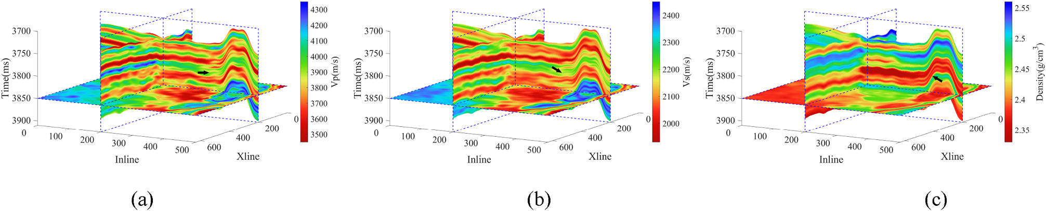

**Fig. 7.** The FSL high resolution inversion results of reservoir parameters. (a) *Vp*; (b) *Vs*; (c) *ρ*.

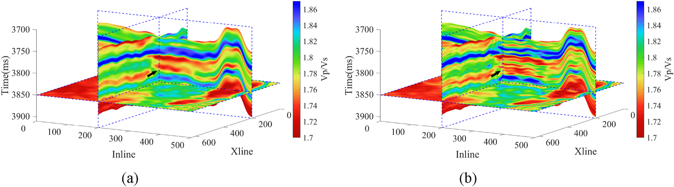

**Fig. 8.** The *Vp/Vs* of reservoir parameters. (a) The conventional inversion results; (b) The FSL-based high resolution inversion results.

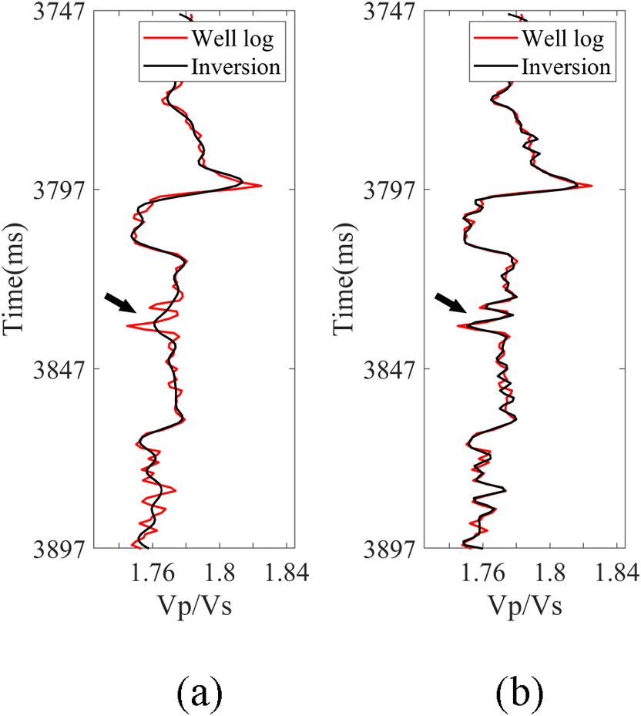

**Fig. 9.** The *Vp/Vs* of reservoir parameters. (a) The conventional inversion re-sults; (b) The FSL-based high resolution inversion results.

206

*T. Chen et al.*  *Artificial Intelligence in Geosciences 3 (2022) 203–208*

trace with a sampling rate of 1 ms. The dominant frequency of seismic data is 40 Hz with an effective frequency band of 8–49 Hz. The target reservoir is TII0, a thin gas formation of Triassic located between the shore-shallow lake mudstone and the TII thick sandstone below. The distribution of lithology is inferred from GR and SP curves in well data. The shore-shallow lake mudstone formation is stable, and its thickness is about 30–48 m. TII0 gas formation has the characteristics of large buried depth (more than 4700 m) and uneven transverse distribution with the thickness is between 1 and 4.5 m. A mudstone intercalation between the TII0 and the lower TII sandstone has an uneven transverse of distribu-tion thickness (3–8 m), locally thickness exceeding 10 m. Fig. 4 shows post-stack and angle-stack seismic data from near to far. The reservoir is sandstone with a small thickness and poor signal-noise ratio (SNR) of pre-stack 3D seismic data. As shown in Fig. 5, we display the proportion of lithology obtained from well log analysis. The yellow and gray coatings in the Figure represent the composition of sandstone to mudstone, respectively. The green curve is the GR log. The difference of P-impedance between sandstone and mudstone in TII0 is not obvious, but the sandstone has the characteristics of low *Vp/Vs*. Therefore, pre- stack inversion of *Vp/Vs* has the potential to identify reservoirs, and the reservoir can be distinguished in a small range.

The seismic data from each angles need to be normalized at the beginning, and then 2 wells are used to construct the initial low- frequency model for the conventional pre-stack inversion. The initial model of the well position is obtained by 12 Hz low-pass filtering of the well data, and then extrapolated to the remaining CDPs positions by interpolation. The 3D pre-stack inversion results of reservoir parameters based on low frequency constrained (Huck et al., 2010). Due to the poor quality of seismic data, conventional inversion results show low reso-lution, which cannot meet the needs of accurate reservoir identification.

For improving the resolution of reservoir parameters, we take the conventional inversion results as the auxiliary dataset for FSL inversion, while the scarce training dataset only has 16 valid well log. In addition to the well log used to construct the scarce dataset, one well that was not involved in the network training process was used as a blind well to test the effectiveness of the results. The auxiliary dataset is used to pre-train the network, and the scarce training dataset will re-train the network and adjust the weight of the network. We performed about 10 epochs to re-train the network. Detailed desc-riptions of A-net network parameters are presented in Table 1. Such as input channels (Ic), output channels (Oc), convolution kernel size (Ks), batch size (Bs), input data height (Ih).

After re-training, we use the trained network to predict *Vp*, *Vs* and *ρ* for the all CDPs positions in working area. It can be seen that retraining network with well log yields higher resolution results than conventional inversion, especially at the black arrow markers (Figs. 6 and 7). Fig. 8 shows the *Vp/Vs* constructed from the inversion results. The black arrow in Figs. 8 and 9 indicates the location of the target gas formation TII0. The inversion effect at this location in FSL-based inversion shows that the boundary between TII0 and surrounding mudstone is clear, and the thickness information of this formation can be accurately identified. We can see that the FSL-based inversion shows several thinner sandstone layers, while the conventional inversion shows a thicker sandstone response. A comprehensive comparison of the two methods inversion results shows that FSL-based inversion method can improve the reso-lution and accuracy of inversion results in pre-stack seismic inversion. Although the number of valid labeled data is small, the resolution of result is still acceptable. If the number of label is enough, we will get a better result.

**3. Conclusion**

In this paper, we propose a high resolution pre-stack seismic inver-sion method for reservoir parameters based on FSL. It contains a specially designed A-Net architecture. Through a field data example, we demonstrated the application of this network in resolving a high reso-lution pre-stack seismic inversion problem. The results show clear

207

*T. Chen et al.*  *Artificial Intelligence in Geosciences 3 (2022) 203–208*

Sun, J., Innanen, K.A., Huang, C., 2021. Physics-guided deep learning for seismic inversion with hybrid training and uncertainty analysis. Geophysics 86 (3), R303–R317. <https://doi.org/10.1190/geo2020-0312.1>.

208